**Economics of the $2 bill during CNY**

Question:

According to Chinese tradition, the red packet stands for the blessings that elders wish for their younger family members. Blessings and new things are associated with Chinese culture, indicating that new and crisp bills should be used when giving red packets. This leads to banks printing large amounts of new $2 notes each year during the festive season. However, despite this, I often hear adult family members complaining about the long queues at banks to collect the new notes and the inability to obtain the total amount of notes they might require. Discuss the economic reasons for this annual phenomenon.

Answer:

A classic example of a shortage in, in reality, be seen outside banks before the CNY period, when old $2 notes must be exchanged for new ones. Furthermore, the fact that each individual is limited to exchanging a certain number of new notes highlights rationing, another sign of a shortage. In utilizing the economic model to analyze this shortage, we can also observe that in this instance, the $2 bill is also perceived not only as currency, but also as a good that has a certain supply and demand, as well as other factors that will determine the final price and quantity.

During the CNY season, demand for new, crisp $2 bills results from the traditional belief of the need for new notes. As a result of this surge in demand, a shortage now occurs as the quantity supplied by the central bank, the Monetary Authority of Singapore (MAS), is less than the quantity demanded by Singaporeans. This shortage manifests in the above-mentioned situations of long queues and reservations at participating bank outlets. In response to this surge in demand, MAS prints approximately 100 million new $2 notes for exchange with old notes.

However, the money supply needs to be kept constant and new notes cannot be printed due to the fear of inflation. There cannot be an increase in the overall supply of $2 notes in response to the increase in demand caused by CNY traditions. As such, a quantity of $2 notes equivalent to that which is printed needs to be destroyed in response. But it is costly to print and subsequently destroy these old notes. This process is also unsustainable and considered detrimental to the environment, creating a negative externality. As such, this limits the number of new notes that MAS can print; hence shortage thus cannot be resolved by just printing new notes.

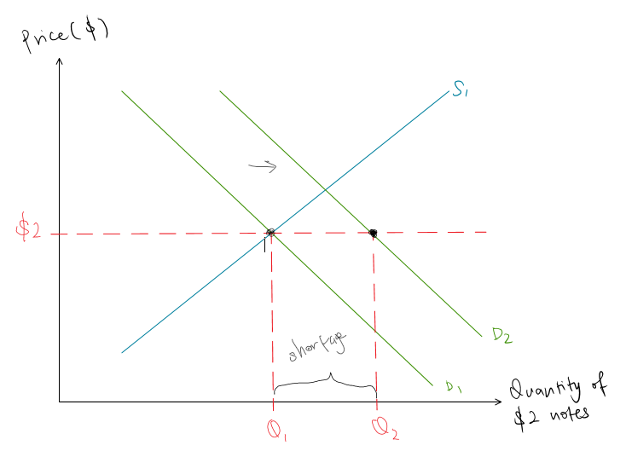

As Chinese tradition mandates new $2 notes, hence one would think they are price inelastic. However, there are many substitutes such as the old $2 notes, coins and other note denominations, making them highly price elastic. In the case of a good with a price elastic demand, a shortage may be resolved through a price increase in theory. Since the new $2 notes are price elastic, this suggests that a slight increase in price would lead to a more than proportionate decrease in demand. Therefore, in theory, this should decrease the quantity demanded by the new $2 notes. In practical terms, this can be done by banks charging a small premium when buyers come to ‘buy’/exchange for the new $2 notes.

Conversely, from the perspective of consumers/buyers, the $2 note is viewed as money used to make purchases rather than a good of its own. The association of price with the $2 note is much stronger than the association of it as a good. However, this is not always the case. Looking at examples of vintage notes or limited-edition notes, buyers are willing to pay above their monetary value to purchase the notes due to their added value as a collectible. These notes would also not conventionally be used for purchases in the market, although they are still legal tender. But newly printed $2 notes do not have this additional value of being collectibles that a hobbyist might demand and thus cannot be sold at prices above their monetary value. As a result, people are unwilling to pay for a new, crisp $2 note if its price does not match its economic value of $2. Hence, an increase in the price of $2 notes would result in severe backlash from the public, illustrating their resistance to a price change. As a result, this prevents banks from charging a slight premium for the exchange of $2 notes to increase prices and reduce demand to eliminate the shortage.

As a result, resolving the shortage by increasing prices to reduce demand is impossible. Hence, the alternative is to make changes that might cause a shift in supply to determine the shortage. There is thus only one viable solution: MAS has to increase the supply of new $2 notes, and in turn, they must destroy the old $2 notes to prevent excess money supply from potentially leading to inflation.

But, as was mentioned above, the destruction and printing of large quantities of new notes each year are exceptionally costly and unsustainable in the long run. To reduce the long queues at the banks and the possible damage to the environment due to the burning of the notes in the long term, the MAS has begun encouraging citizens to adapt to e-ang paos. Using this alternative to ang paos eliminates the need for physical $2 notes since payment will now be made electronically, which reduces the quantity demanded of physical notes. Thus, a significant amount of shortage will be reduced.

What is worth considering, however, is that a part of the population - the older generations - may be less familiar with these electronic payment methods and thus would still need to use physical ang paos. Sticking to their beliefs of using the new notes and the physical ang paos the new initiatives only reduces their demand by a smaller percentage than expected, as only the younger generation may be adaptive to this new change. As such, the shortage cannot be eliminated entirely without other policies to ensure these groups in society are enabled to change as well.

Total word count: 1038